Infrastructure Description v2

Infrastructure Integration Roadmap Task

**Task Type(s)**: Coordination  
**Start by phase**: Integration  
**Complete by phase**: Ongoing  
**RP role(s)**: Resource Integration Coordinator, Documentation and knowledge base contact(s),

# Summary

ACCESS infrastructure that is visible to researchers, resource providers, developers, other ACCESS awardees, or the broader community must be described. ACCESS resource providers, ACCESS projects, and other ACCESS affiliated online service providers (i.e. science gateways, etc.) enter basic information about their organization and then describe the infrastructure that they operate in the Cyberinfrastructure Description Repository (CiDeR). Audience relevant summaries of these descriptions are displayed in ACCESS websites.

Initial setup involves resource integration coordinators gaining administrator access to CiDeR so they can authorize others in their organization to enter and maintain infrastructure descriptions. This task should take ~½ hour. Organization staff enter initial descriptions and maintain accurate infrastructure descriptions in CiDeR. This task should take ~1 hour/year per resource.

This integration task replaces and improves the [Infrastructure Description v1 task](https://docs.google.com/document/d/1RJCEFLL1vjSOo-plBRK67qwTePXahbvsuZVoGOlYTFg). Operators that completed the v1 task already completed this task.

# Prerequisite tasks

# None

# Support Information

For assistance with this task see the *Support Information* section in the *Integration Roadmap Description*.

# Detailed Instructions

Organization staff access CiDeR at <https://cider.access-ci.org/login>.

## Initial CiDeR Setup

If your organization already has CiDeR/RDR access, skip to step C.

Submit a ticket with the Subject “New CiDeR Organization: at <https://support.access-ci.org/open-a-ticket>.

* Organization logo URL or attached file
* Organization public URL
* Organization PI/director name
* Organization PI/director email address
* External Data Posting
  + Organization ID Type either [GRID](https://www.grid.ac/) or [RINGGOLD](https://www.ringgold.com/ringgold-identifier/)
  + Organization ID
  + City, State, and Country
* The ACCESS usernames of individuals that will be CiDeR administrators for their organization. These individuals will be able to grant other individuals access to maintain infrastructure descriptions. A single individual can be the CiDeR administrator and the person entering and maintaining descriptions.

Submitted organization information will be entered by a CiDeR in a form as shown below and used to grant access to CiDeR administrators.

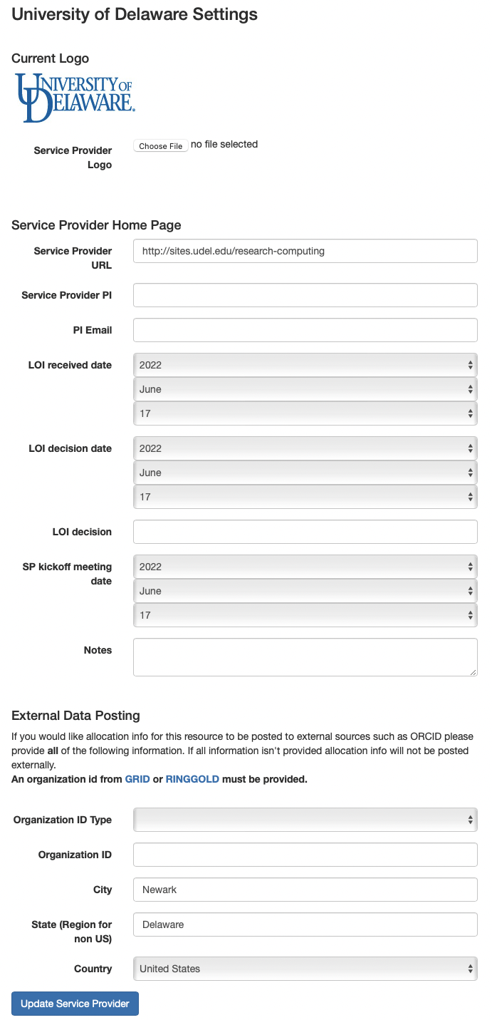

## Provide CiDeR access to other organization staff

The resource integration coordinator grants other organization staff access to enter and maintain infrastructure descriptions:

* Select “Service Providers” or “Organizations” along the top.
* Click on your “Organization” name.
* Click on “Administrators”.
* Add additional Organization Admins who may enter and update your organization resource information.

## Enter Resource Descriptions

Organization staff enter new infrastructure as detailed in the Quick Start Guide and User Guide:

<https://cider.access-ci.org/cider_manual_full.pdf>

Steps:

* Select “Resources” along the top.
* Click on your “Add a Resource” to add a new resource, or click on a resource name if your resource already exists.
* Enter as much information as possible in this first form
* Select a “Resource Type” at the bottom of the screen and “Create Resource”
* Enter as much information as possible in this second form

## Enter Resource Conversion Factors

Skip this section if you resource is not ACCESS allocated

Page 16 of the CiDeR/RDR Manual has instructions for entering a “conversion factor”. This is the NU conversion factor of your resource, divided by 21.576. This will be used to compute your initial marketplace exchange rate. **For most compute resources, you should NOT change the conversion factor that you already have listed.**In a later stage of ACCESS, additional tools will be created to manage your variable marketplace exchange rate.

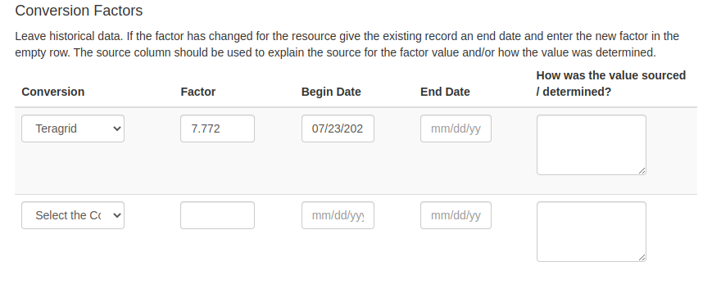

## Maintain infrastructure descriptions

Information in CiDeR should be kept up to date, and reviewed for accuracy at least once a year.

# Document Management

**Status**: Official

**Official date**: 2/15/2023

**Coordinators**: JP Navarro, ACCESS Operations; Nathan Tolbert, ACCESS Allocations

**Last revised date**: 2/3/2023

**Retired date**: